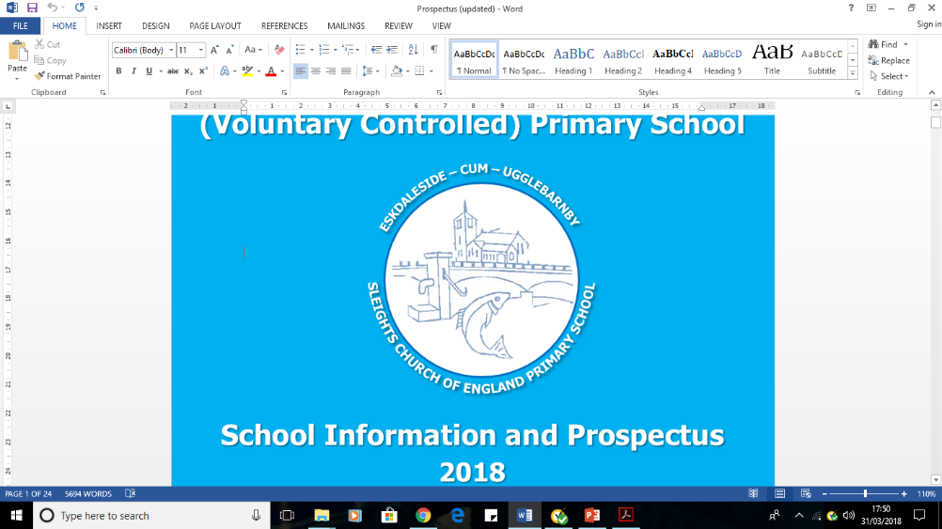
Sleights Church of England (Voluntary Controlled) Primary School
Working together to be happy; to flourish; to succeed; through our Christian Values of perseverance, respect and trust.

Weekly Newsletter 22nd January 2021

News from Sleights
Another week of excellent home and school learning has come to an end. Each day, we continue to be blown away by the incredible efforts and achievements of our children, families and staff. A huge thank you to everyone for their continued, ongoing support at Sleights.

This week, we have once again seen and heard about a huge variety of work that is taking place outside of school. It is always lovely to celebrate things at home with you all, so a big thank you for continuing to share these things with us.

In school, we welcomed back our Key Stage Two bubble this week, following closure due to a positive case last week. Thank you to all families for their patience and understanding here. We appreciate the situation is a challenge for everyone.

There continues to be discussion and uncertainty about when lockdown restrictions will end and when schools are due to reopen for all children. We hear the same headlines and information as families, so understand the frustration attached to not knowing when things will go back to how they were. Please be reassured that, for however long we continue to work in this way, we will continue to do it together and as one school family.

Whilst the school building is closed to most children, we are all still here and want to remind families that if you need anything from us, please send me an email, or drop us a message on Tapestry and we will do our best to help.

Have a restful weekend with your families.
Scott Grason, Headteacher
headteacher@sleights.n-yorks.sch.uk
Checking in
Thank you to you all for registering safely from home. Just a reminder to email us each day, please. Lots of families are choosing to reply to the 10.30am* reminder text. If this works best for you, it is OK to register like this too!
*Apologies that one day this week, the reminder text was sent in error a few hours earlier than planned!

Celebrating learning at home
With lots more great learning taking place at home, there is a huge amount to celebrate again this week!
- Continuing the theme of our “What We’ll Build” whole school book, the Explorers have been investigating tools this week. We’ve seen lots of printing and painting (making some very messy kitchen utensils!) Baking has also been on the learning menu, with children enjoying using tools to create lovely biscuits to enjoy.
- Pioneers have been learning about their homes this week. We have seen lots of the children share photographs of their houses and some of their features. Mrs Hann also took her class on a virtual journey around the globe using Google Earth. We have heard about and seen lots of Pioneer writing and reading at home too. Super!
- Learners and Adventurers have been busy singing this week to help learn the days of the week and months of the year. Families have told us how catchy the song is (sorry about that!) Children at home and in school have also enjoyed planning adventures with their time machines. We have also loved seeing the children make their own clocks and practise time telling at home. Great work Key Stage One!
- The Discoverers and Leaders have worked hard to describe how objects work in two ways – the factual way and a fantasy way. There have been some brilliant ideas shared! We have seen an artistic side from families at home this week too, with some lovely 3D models made by many of you. The Discoverers have spoken very positively about their French lesson this week too. We have really enjoyed seeing French at home – such good fun!
- Outside of the home school classroom, it has been brilliant to also hear about many other lovely activities. Lots of families have been working together to create meals, with lots of chopping and cutting taking place. We have also seen jigsaws, den building, research, lots of walks and even yoga! Such a huge array of simply brilliant things. Thank you!
Well done Team Sleights for excellent learning at home!

Covid-19 Staff Testing
You may have heard that primary school staff are now taking part in twice weekly testing for Covid-19. These tests are to identify asymptomatic cases of Covid-19 in the community and are a government drive to continue fighting infection rates. To make families aware, school staff will self-administer lateral flow tests at home regularly. This may impact upon our key worker provision in school if staff test positive, but we will inform families as soon as possible if this is the case.
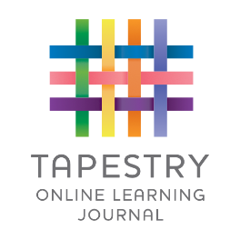
Tapestry
We are pleased that the issues we have faced with Tapestry now appear to be resolved. So much great work from home has been posted this week, which is just brilliant to see. Just a reminder that work submitted is only seen by school staff, unless permission is given to share this with friends as part of a celebration.
Records on Tapestry show that lots of our families are now logging on the night before work is due to be completed to see what is set and plan their days accordingly. We are really pleased that this suggestion from a parent in November is having such a big impact for our families now. On occasion, Tapestry is slightly delayed at posting the work for spot on 6pm, but it does appear very soon after!

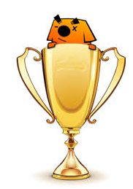
Sumdog Champions
It has been great to see lots of our children busy on Sumdog. Each week, a challenge is set by staff to allow the children to practise their maths skills, whilst earning coins to spend in the Sumdog store. We are looking closely at how the children are accessing Sumdog and each week will share the most active classes with you.

Well done to LEADERS who were our most active class last week. However, DISCOVERERS were very closely behind the Leaders. Let’s see which class tops the board next week!

Resource Box
Don’t forget that our resource box is still in use and outside of school for you to help yourselves. We make sure that there is always a collection of useful equipment and books, but if you think there is something you need, please let us know.
A focus on feedback and assessment when learning at home
Thank you to everyone for your brilliant contributions to Tapestry. Today, I wanted to share some the ways our staff give feedback to work completed at home and make an assessment on what to do next. This is obviously a crucial part of teaching!

Some of the ways we give feedback on work includes:
- Comments on Tapestry after an observation has been posted. This allows us to celebrate great ideas and achievements, as well as suggest how something could be made even better!
- In the classroom, we use blue ink to mark the children’s work. Some pieces of work uploaded to Tapestry will be edited by staff, to include blue marking using the school’s feedback policy that would be used if we were in school.
- We give lots of verbal feedback to children in the classroom, so are continuing to do the same when learning is taking place at home. You may see a new video be added to observations you post. This is when a member of staff is looking at the children’s work on screen and sharing the successes and next steps. This helps us to give really specific suggestions! Staff will write a comment to let you know a feedback video has been posted.

Some of the ways we make an assessment on work includes:
- Reviewing how well the children have done when completing a task. This could be seeing the number of correct answers, or how a task has been finished.
- Chatting with families and the children allows us to hear from you what we are getting right and if the work needs to be changed. Please do keep letting us know!
- Quizzes and challenges are a great way to see how well the children have understood something, whilst they enjoy playing a game. Activities such as Sumdog allow us to set particular questions to find out how well children understand, whilst not adding any pressure to them.

Sleights is a nut free and peanut free school.

